Python Programming Lab -1
Name:Syeda Afifa Fathima
Roll no:2503B05142
Branch:M.Tech (CSE)

Set 2
- Q1. Write a Python function `is_prime(n)` to check if a number is prime. Use an AI coding tool to generate and justify a set of test cases before implementation. Pass all generated test cases.
Code:

a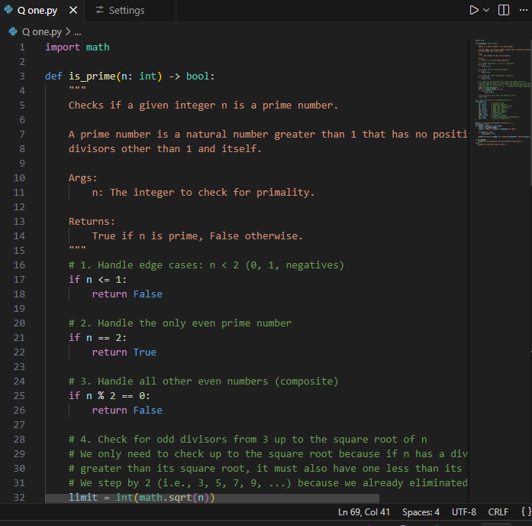

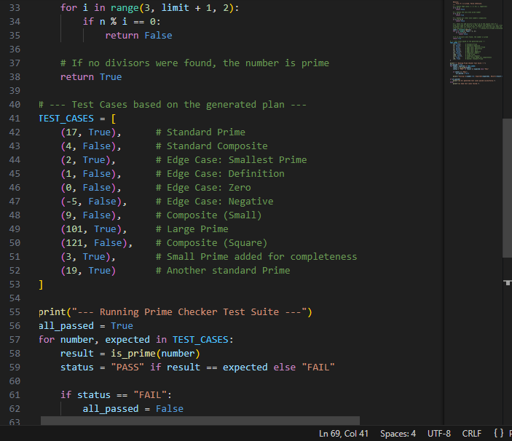
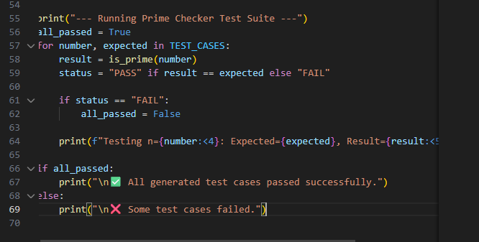
Output:
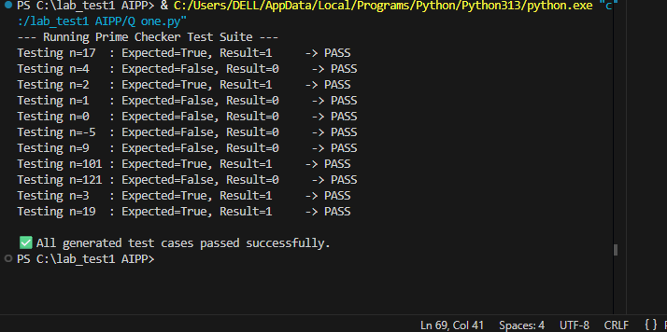

Q2(2.1)Python code for Rectangle Class — With AI-Generated Docstrings & Inline Comments

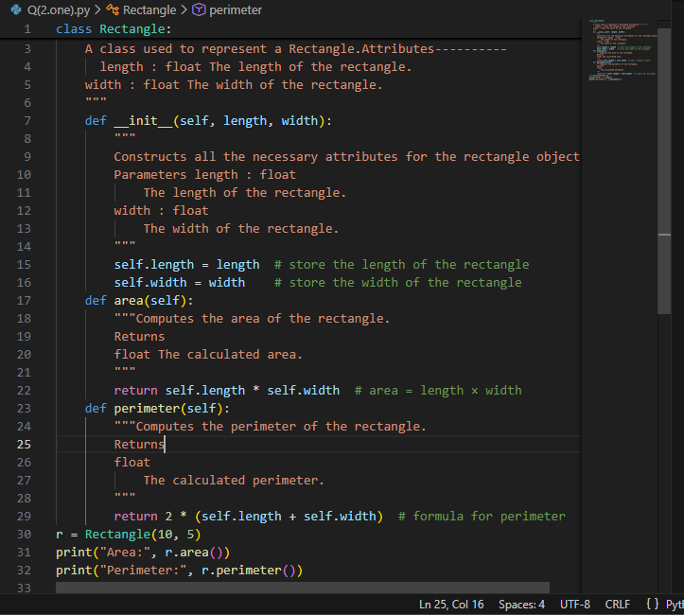
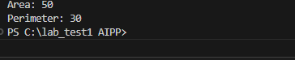
Output:

Q2(2.2). Write a python code for Rectangle Class — With Manually Written Documentation
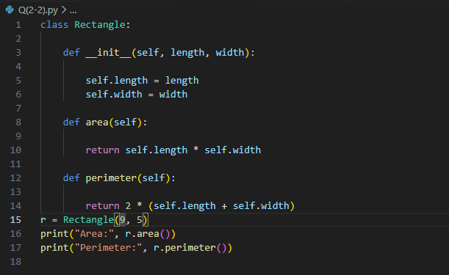

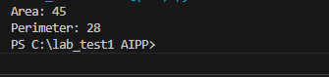
Output:

